Notes and task on AWS secret manager:
AWS Secrets Manager is a fully managed AWS service used to securely store, manage, and retrieve sensitive information called secrets.
Examples of secrets:
- Database passwords
- API keys
- OAuth tokens
- SSH keys
- Application credentials
Instead of hardcoding passwords inside applications, AWS Secrets Manager stores them securely and allows applications to access them when needed.

Why AWS Secrets Manager Is Important
Without Secrets Manager:
Application Code
↓
Hardcoded Password
Problems:
- Security risk
- Difficult to rotate passwords
- Credentials exposed in Git repositories
- Hard to manage at scale

With Secrets Manager:
Application
↓
AWS Secrets Manager
↓
Secure Secret Retrieval
Benefits:
- Centralized secret storage
- Encryption
- Automatic rotation
- Secure access control

Key Features
Secure Storage
Secrets are encrypted using:
AWS Key Management Service (AWS KMS)

Automatic Secret Rotation
Secrets Manager can automatically rotate:
- Database passwords
- API credentials
Supported databases include:
- MySQL
- PostgreSQL
- Oracle
- SQL Server
- Amazon RDS

Fine-Grained Access Control
Uses:
- IAM roles
- IAM policies
Only authorized users/services can access secrets.

Audit and Monitoring
Integrated with:
- AWS CloudTrail
- Amazon CloudWatch
You can monitor:
- Who accessed secrets
- When secrets changed

How AWS Secrets Manager Works
Step-by-Step Flow
Application
↓
Requests Secret
↓
AWS Secrets Manager
↓
Returns Encrypted Secret

Example
Suppose your application connects to MySQL.
Instead of this:
password = "mydbpassword123"
You store the password in Secrets Manager.
Application retrieves it securely during runtime.

Common Use Cases
Database Credentials
Store:
- Username
- Password
- Connection strings

API Keys
Examples:
- Stripe API keys
- Twilio credentials
- Payment gateway tokens

Third-Party Authentication
Store OAuth tokens and client secrets securely.

DevOps & CI/CD
Used with:
- Jenkins
- GitHub Actions
- Kubernetes
- ECS/EKS

Secret Rotation
One of the most powerful features.
What Is Rotation?
Automatically changing credentials periodically.
Example:
Old Password → New Password
This reduces security risks.

Rotation Workflow
Secrets Manager
↓
Lambda Function
↓
Update Database Password
↓
Store New Password
Typically implemented using:
AWS Lambda
Selected the last other keys option and then created it with username and password name:
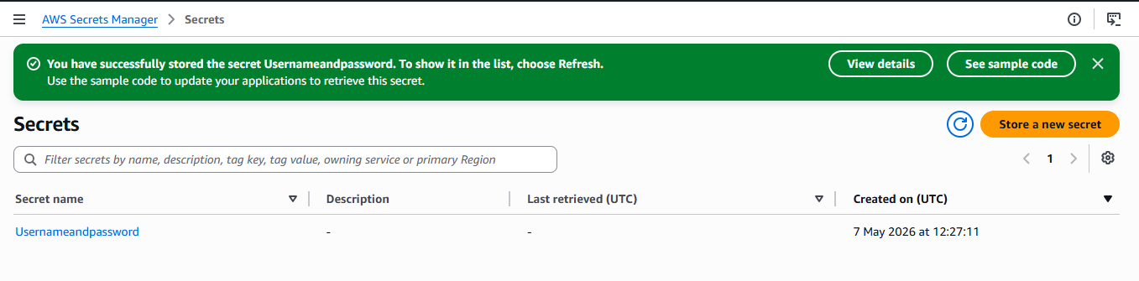
Then click on the username and password name and then scroll down then click on retrieve secret value then it will show the username and password: 